TO : AH

CC : GM, CSS

FROM : MIS

DATE : 26th of FEBRUARY, 2019

SUBJECT : CREDIT APPLICATION - CI CODE APPROVAL USING TEXT SMS

Goodday,

In connection with the implementation of CI CODE APPROVAL FOR CREDIT APPLICATION USING ANDROID PHONE, we would like to inform you that approval of CI Quick Matches using TEXT SMS is now ready.

WHEREIN: MC Credit applications’ APPROVAL CODE with quick match result of for CI (ex: CI000000U) can now be requested using TEXT SMS.

WHEREIN: Field specialists mobile number must be registered to use the TEXT SMS CI APPROVAL system feature.

WHEREIN: Branch head should inform the TeleMarketing team for their updated branch service phone number.

Moreover: All other QM result will remain as is, wherein; Branches seek CSS assistance if needed.

Attached herewith are the procedures on how to use the said system feature. Kindly disseminate this IOC to your respective branches.

Any questions and clarifications feel free to contact us.

Thank you and please be guided accordingly.
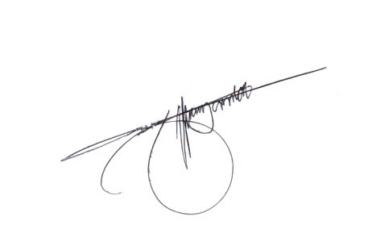
Sincerely Yours,

Jeffrey T. Yambao
Head, MIS

CREDIT APPLICATION
CI CODE APPROVAL USING TEXT SMS
User Guide

How to register the field specialists’ mobile number?

- The field specialist should inform his branch head that he wants to use the TEXT SMS feature to issue approval code for Credit Applications.
- The branch head will now request to add the mobile number of the field specialist to the CSS Department.
- The CSS Department will request to the MIS Department to add the mobile number of the field specialist on the system code approval authorized list thru email.

How to update the branch service phone number?

- Call the TeleMarketing team and give the current service phone number of the branch.
- The TeleMarketing team will update the branch’ mobile phone number using the TLM system.

How to issue approval on credit applications?

- Using the registered mobile number, the field specialist sends SMS to 09479906531.
- SMS format:

CODEAPPR CA/BRANCHCODE/CLIENTNAME/DATEAPPLIED/RESPONSE/REMARKS

- Wherein:

BRANCHCODE = Requesting Branch code (ex. M001)
CLIENTNAME = Applicant’s name (ex. Capito, Roque Jose Padriguez)
DATEAPPLIED = Application date (ex. 2019-02-21)
RESPONSE = yes if approved; no if disapproved
REMARKS = Approval notes

- Sample text:

Approved application:

CODEAPPR CA/M001/Capito, Roque Jose Padriguez/2019-02-21/yes/has capacity to pay

Disapproved application:

CODEAPPR CA/M001/Capito, Roque Jose Padriguez /2019-02-21/no/applicant is unemployed

Notes:

- For every successful request, Guanzon textblastwill send a response message to the approving field specialists’ and branch service phone number.

Sample response message for approved application:

GUANZON GROUP: CI approval code for Mr/Ms. Capito, Roque Jose Padriguez with application date of 2019-02-21 is A28851142B issued by Amansec, Lito Balcita

Sample response message for disapproved application:

GUANZON GROUP: Mr/Ms. Capito, Roque Jose Padriguez application was disapproved byAmansec, Lito Balcita

- For every unsuccessful request, Guanzon textblastwill send a response message to the approving field specialists.

Requesting approval using unregistered mobile number response message:

GUANZON GROUP: Please make sure that this mobile number is registered for approval code issuance. Kindly inform your branch manager regarding this matter.

Requesting approval using wrong format response message:

GUANZON GROUP: Please make sure to use the preferred format for issuing approval. Thank you.

